**Q.1. Use key value output format to save the output of Session 6 – Assignment 1(Travel Data analysis) and save the output as comma (,) separated instead of tab(\t) separated.**

**Driver**

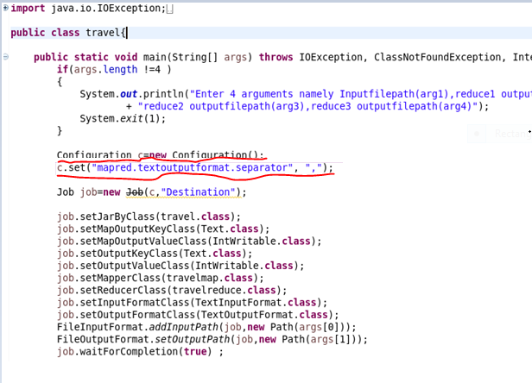

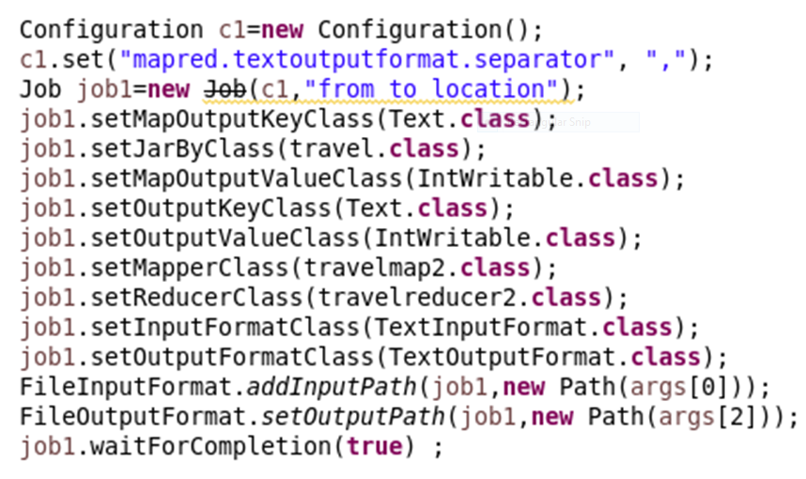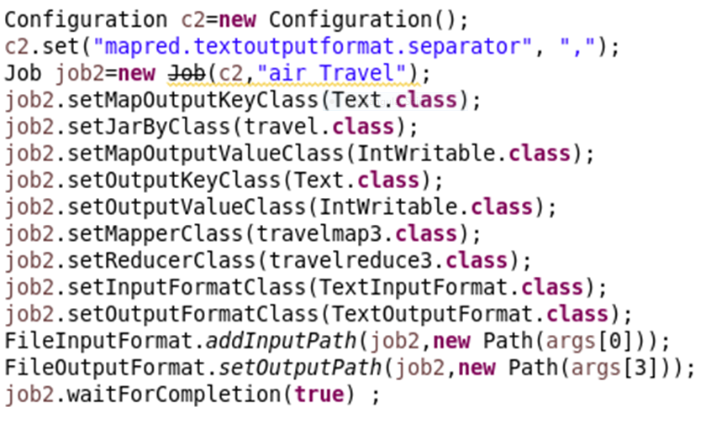

**Find out how many people has chosen their destination as MIA and MCO**

**Mapper**

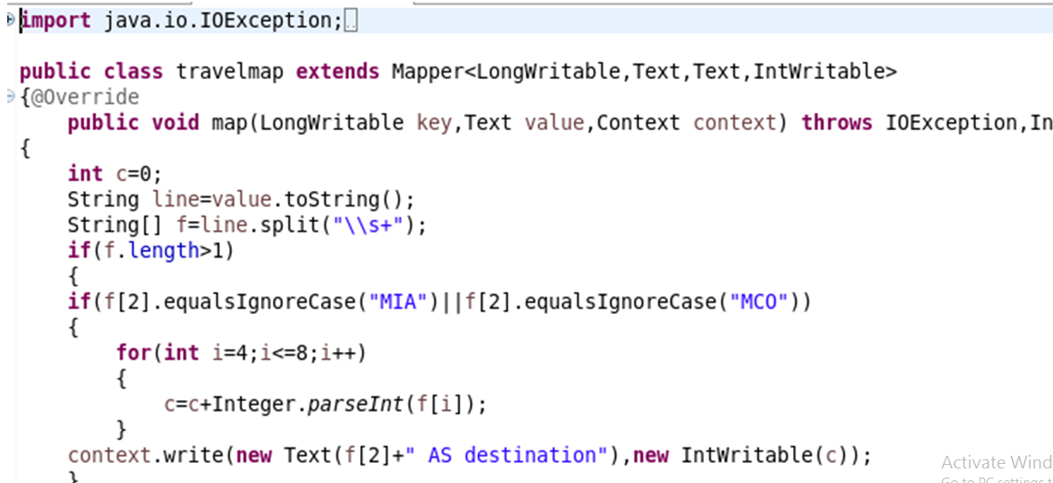

**Reducer**

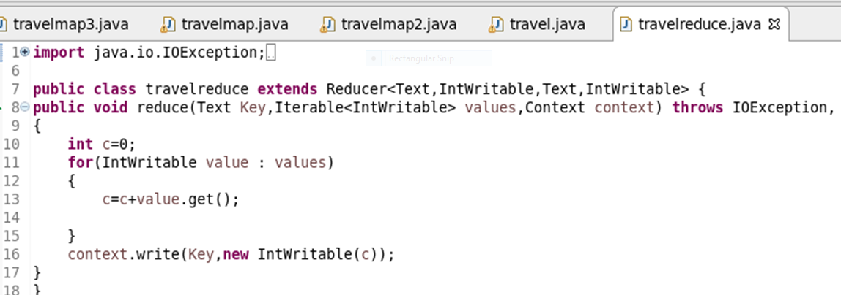

**Find out the number of people undertaken the trips from the places MIA and HOU**

**Mapper**

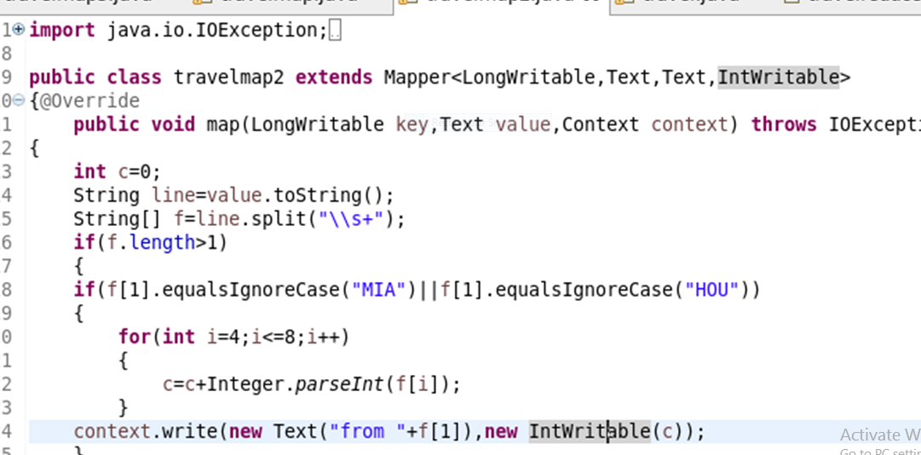

**Reducer**

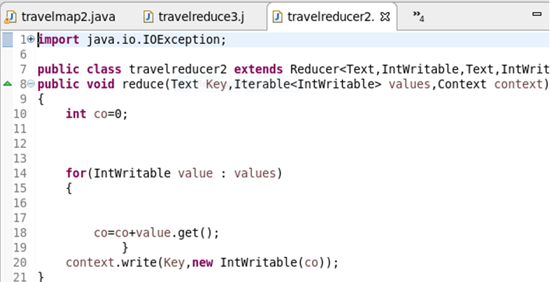

**Find out how many people has chosen airline mode of travel for the places LAS and LAX**

**Mapper**

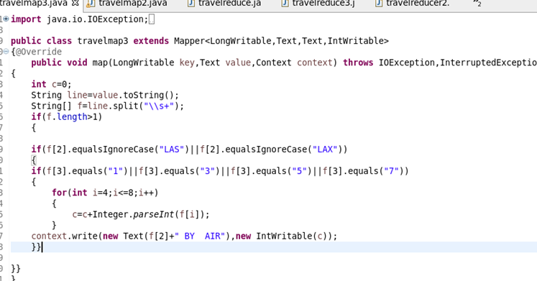

**Reducer**

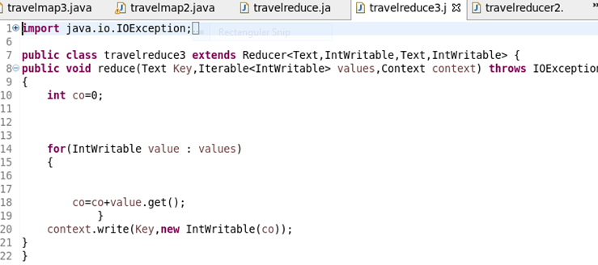

**Output**

